Carbody Structure and Exterior

Introduction

Use

Purpose

Parts List

All figures are assigned to an individual page unless views are required to show a complete listing of equipment.

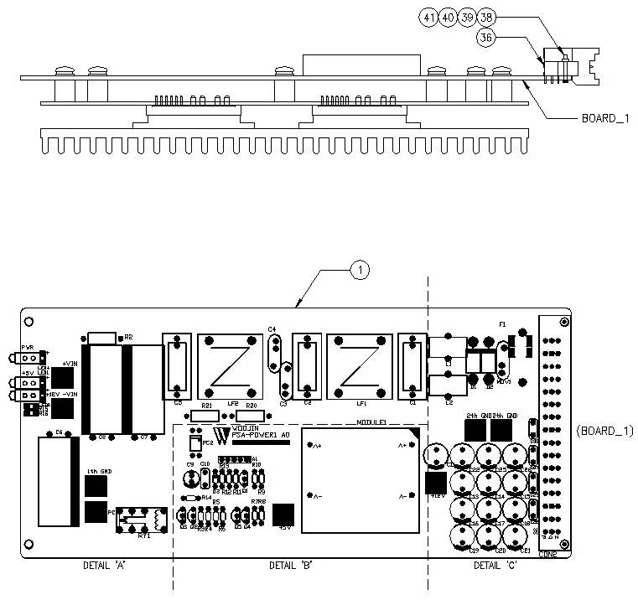

Figure 2.1. PSA Power Board1

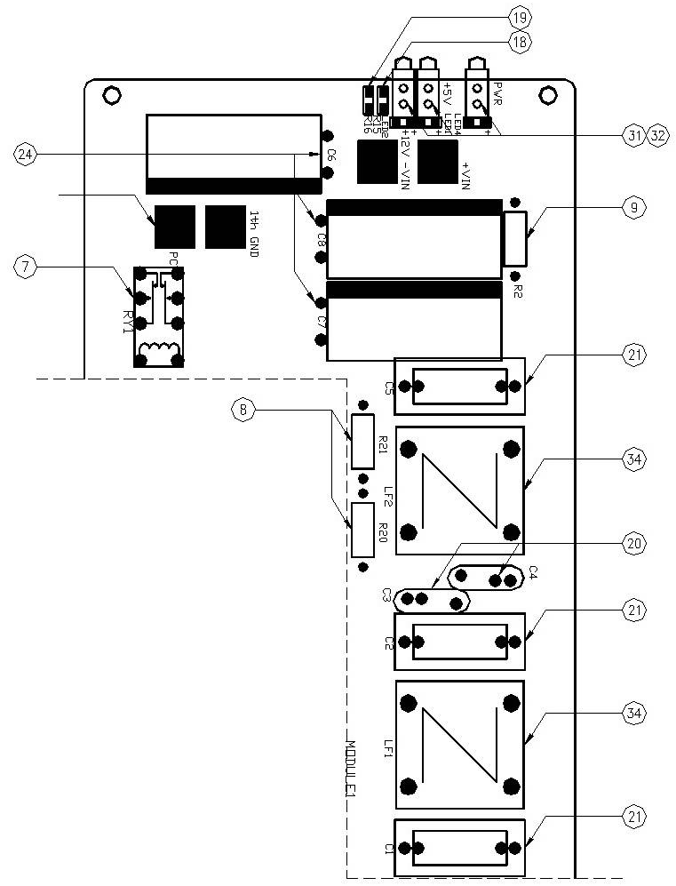

Figure 2.2.1. PSA Power Board1 (Detail A)

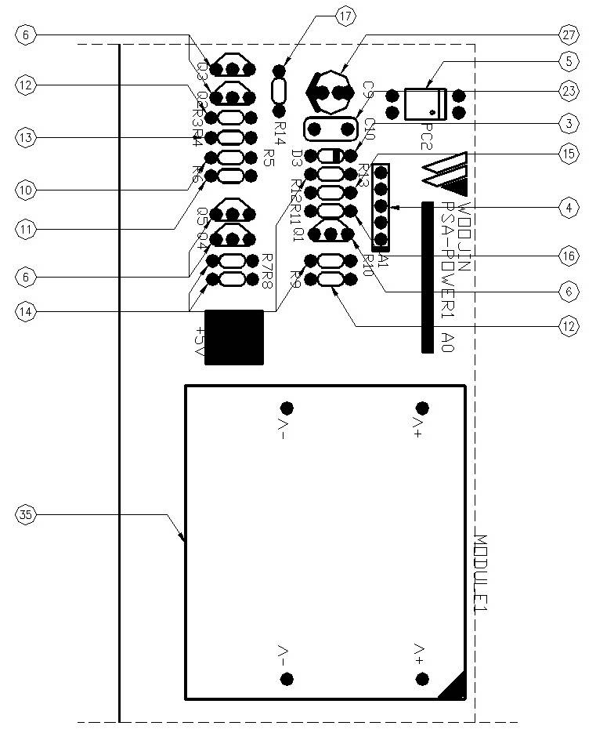

Figure 2.3.2. PSA Power Board1 (Detail B)

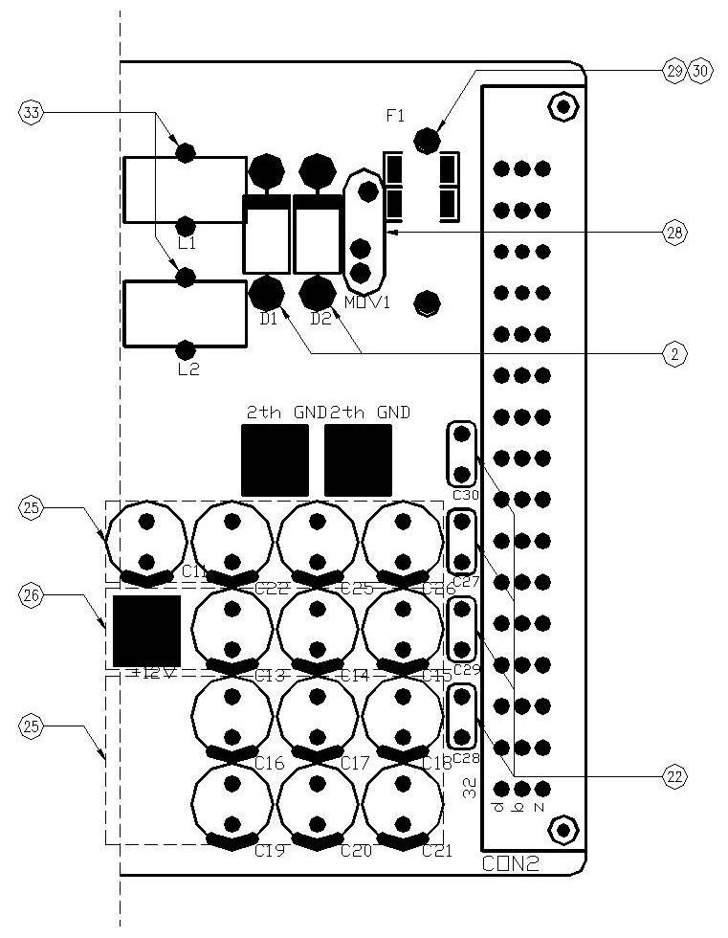

Figure 2.4.3. PSA Power Board1 (Detail C)

Table 1 - Figure 2.1. pSA Power board1
FIG No. | PART NUMBERS |  |  | ITEM DESCRIPTION | VENDOR CODE | QTY
 | HRC | VENDOR | DTP
1 |  | PSA-POWER1 A0 |  | . BOARD, | HANSAEM | 1
2 |  | UF5408 |  | . FAST RECOVERY DIODE | RECTRON  VISHAY | 2
3 |  | 1N4148 |  | . SWITCHING DIODE | FAIRCHARD  VISHAY | 1
4 |  | M51957B |  | . OP AMP | MITSUBISHI | 1
5 |  | PC817  TLP521 |  | . PHOTO COUPLER | SHARP  TOSHIBA | 1
6 |  | KTC3203 |  | . TRANSISTOR-NPN | KEC  FAIRCHARD | 5
7 |  | DS2E-M-DC5V |  | . RELAY | NAIS | 1
8 |  | MORS2W2.2KΩJTB  BLEE244122.2KΩ  MORS2W2.2KΩJT/P |  | . METAL OXIDE FILM RESISTOR | ABCO  RARA  JEIL | 2
9 |  | CRS1/2W3.9KΩJTB  MGR371/2W3.9KΩJTP  RD1/2KT52R3.9KΩJ |  | . CARBON FILM RESISTOR | ABCO  RARA  JEIL | 1
10 |  | MR1/8W43KΩFTB  MFR0318FAEW4302MA  SN1/8KT52R43KΩF |  | . CARBON FILM RESISTOR | ABCO  RARA  JEIL | 1
11 |  | MR1/8W820ΩFTB  MFR0318FAEW8200MA  SN1/8KT52R820ΩF |  | . CARBON FILM RESISTOR | ABCO  RARA  JEIL | 1
12 |  | MR1/8W1KΩFTB  MFR0318FAEW1001MA  SN1/8KT52R1KΩF |  | . CARBON FILM RESISTOR | ABCO  RARA  JEIL | 2
13 |  | MR1/8W10KΩFTB  MFR0318FAEW1002MA  SN1/8KT52R10KΩF |  | . CARBON FILM RESISTOR | ABCO  RARA  JEIL | 1
14 |  | MR1/8W4.7KΩFTB  MFR0318FAEW4701MA  SN1/8KT52R4.7KΩF |  | . CARBON FILM RESISTOR | ABCO  RARA  JEIL | 4
15 |  | MR1/8W560ΩFTB  MFR0318FAEW5600MA  SN1/8KT52R560ΩF |  | . CARBON FILM RESISTOR | ABCO  RARA  JEIL | 1
16 |  | MR1/8W470KΩFTB  MFR0318FAEW4701MA  SN1/8KT52R470KΩF |  | . CARBON FILM RESISTOR | ABCO  RARA  JEIL | 1
17 |  | MR1/8W3KΩFTB  MFR0318FAEW3001MA  SN1/8KT52R3KΩF |  | . CARBON FILM RESISTOR | ABCO  RARA  JEIL | 1
18 |  | RC3216J102CS |  | . FILM CHIP RESISTOR | SAMSUNG | 1
19 |  | RC3216J242CS |  | . FILM CHIP RESISTOR | SAMSUNG | 1
20 |  | SDE2E472  HCFZ2G472MAAP10 |  | . CERAMIC CAPACITOR | SAMWHA  NETRONTECH | 2
21 |  | PCX2-335-MJ474  MPX474K31D5 |  | . FILM CAPACITOR | PILKOR  CARLI | 3
22 |  | PCMT-365-85104  EB1J104K |  | . FILM CAPACITOR | PILKOR  SAMHWA | 4
23 |  | PCMT-365-75474  EB1J474K |  | . FILM CAPACITOR | PILKOR  SAMHWA | 1
24 |  | KXL(NXB)63VB1000M7.5TP  RD1J108M16025PA |  | . ELECTROLYTIC CAPACITOR | SAMYOUNG  SAMWHA | 3
25 |  | LXZ10VB1000M3.5TP  RD1A108M1012MPA |  | . ELECTROLYTIC CAPACITOR | SAMYOUNG  SAMWHA | 9
26 |  | KMG(NHA)400VB4R7M5.0TP  RD2G475M1012MPA |  | . ELECTROLYTIC CAPACITOR | SAMYOUNG  SAMWHA | 3
27 |  | KMG50VB1M2.0TP  RD1H105M05011PA |  | . ELECTROLYTIC CAPACITOR | SAMYOUNG  SAMWHA | 1

FIG No. | PART NUMBERS |  |  | ITEM DESCRIPTION | VENDOR CODE | QTY
 | HRC | VENDOR | DTP
28 |  | INR14D151  SVC151D-14A |  | . VARISTOR | AMOTECH  SAMWHA | 1
29 |  | 0215010.MXP  55T 250V 10A |  | . FUSE | LITTLE FUSE  ORISEL | 1
30 |  | FH51  GF205 |  | . FUSE HOLDER | YEONHO  GEO YOUNG | 1
31 |  | LS-SP150YG34-5 |  | . LED | LONGSUM | 3
32 |  | 7511A85 |  | . LED LIGHT PIPE | CML | 3
33 |  | 47uH/10A, Φ12, BLUE |  | . POWER INDUCTOR | TAESUNG  DAEKWANG | 2
34 |  | 2mH/6A, Φ27, RA |  | . LINE FILTER | TAESUNG  DAEKWANG | 2
35 |  | PP6-12-5 |  | . DC/DC CONVERTER | TDKLAMBDA | 1
36 |  | 109-40064 |  | . RECEPTACLE | EPT | 1
37 |  | ROUND, M3.5 X L8mm |  | . BOLT |  | 7
38 |  | ROUND, M2.6 X L12mm |  | . BOLT |  | 2
39 |  | HEXA, M2.6 |  | . NUT |  | 2
40 |  | FLAT, M2.6, D4.8mm |  | . WASHER |  | 2
41 |  | SPRING, M2.6, D4.8mm |  | . WASHER |  | 2

